CI CD LAB EXPERIMENT -3

(BY: AMAN TYAGI)

Aim: Jenkins integration with Github and Maven

1. Run your Jenkins dashboard
2. Make a new item and select maven project (You need to install the plugin of Maven if not installed )
3. In the config setting select Git as the SCM and enter the url of the repo where maven project is pushed

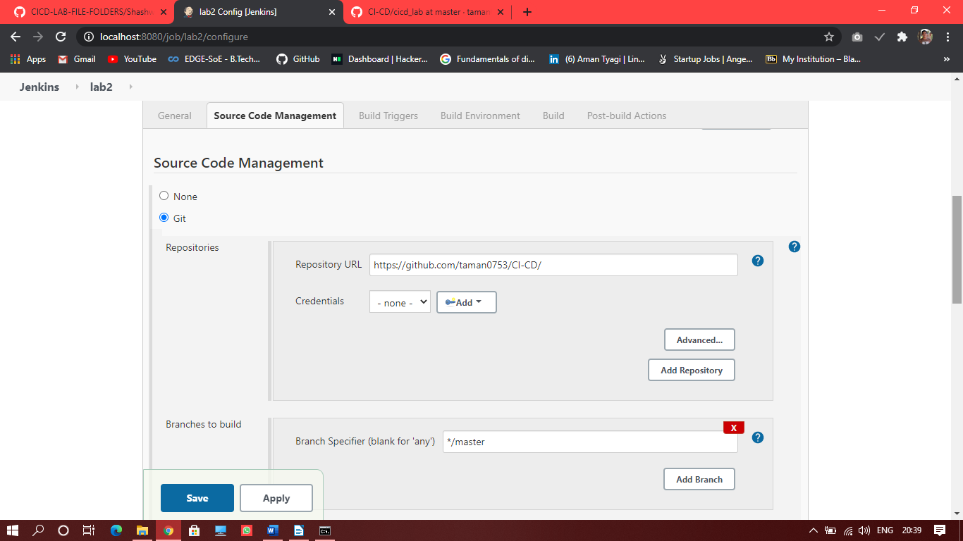

1. Go to the build section and update the location of pom.xml
2. In the goals specify “clean, test and install” as the maven goals

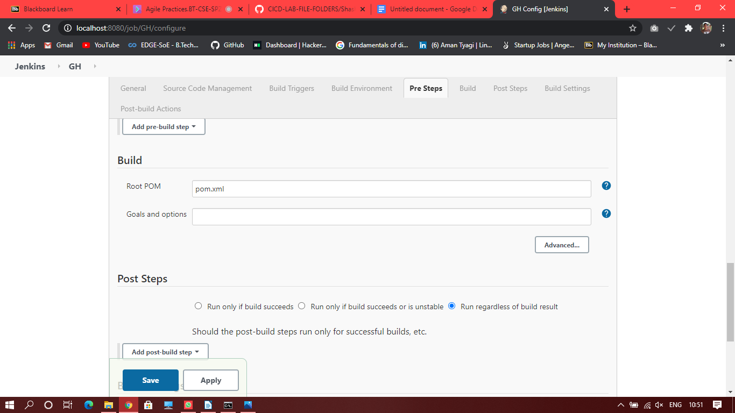

1. Save the changes

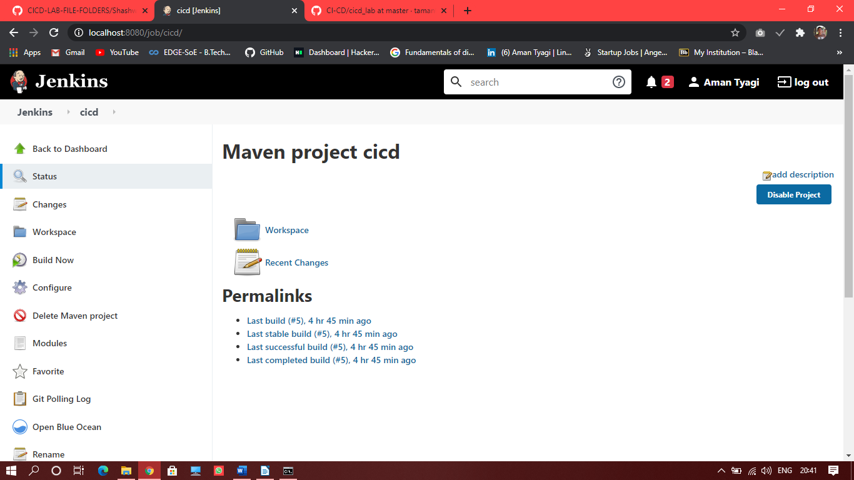

1. Build the project
2. Build will start and you can see the console output for “Build success”

See the screenshot on the next page.

